baseurl: http://127.0.0.1:3002/api

- Dashboard Page:
No Dashboard Page
Old UI:
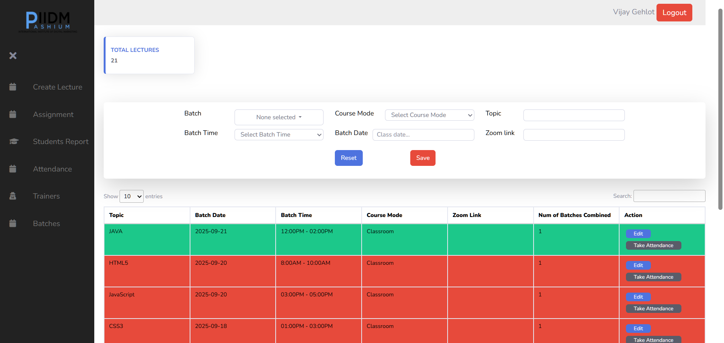
New UI:
1. Get Total Batches: /batch/select-paginate-advanced?draw=1&columns%5B0%5D%5Bdata%5D=batch_num&columns%5B0%5D%5Bname%5D=&columns%5B0%5D%5Bsearchable%5D=true&columns%5B0%5D%5Borderable%5D=false&columns%5B0%5D%5Bsearch%5D%5Bvalue%5D=&columns%5B0%5D%5Bsearch%5D%5Bregex%5D=false&columns%5B1%5D%5Bdata%5D=&columns%5B1%5D%5Bname%5D=&columns%5B1%5D%5Bsearchable%5D=true&columns%5B1%5D%5Borderable%5D=false&columns%5B1%5D%5Bsearch%5D%5Bvalue%5D=&columns%5B1%5D%5Bsearch%5D%5Bregex%5D=false&columns%5B2%5D%5Bdata%5D=name&columns%5B2%5D%5Bname%5D=&columns%5B2%5D%5Bsearchable%5D=true&columns%5B2%5D%5Borderable%5D=false&columns%5B2%5D%5Bsearch%5D%5Bvalue%5D=&columns%5B2%5D%5Bsearch%5D%5Bregex%5D=false&columns%5B3%5D%5Bdata%5D=batch_date&columns%5B3%5D%5Bname%5D=&columns%5B3%5D%5Bsearchable%5D=true&columns%5B3%5D%5Borderable%5D=false&columns%5B3%5D%5Bsearch%5D%5Bvalue%5D=&columns%5B3%5D%5Bsearch%5D%5Bregex%5D=false&columns%5B4%5D%5Bdata%5D=batch_time.name&columns%5B4%5D%5Bname%5D=&columns%5B4%5D%5Bsearchable%5D=true&columns%5B4%5D%5Borderable%5D=false&columns%5B4%5D%5Bsearch%5D%5Bvalue%5D=&columns%5B4%5D%5Bsearch%5D%5Bregex%5D=false&columns%5B5%5D%5Bdata%5D=branch.name&columns%5B5%5D%5Bname%5D=&columns%5B5%5D%5Bsearchable%5D=true&columns%5B5%5D%5Borderable%5D=false&columns%5B5%5D%5Bsearch%5D%5Bvalue%5D=&columns%5B5%5D%5Bsearch%5D%5Bregex%5D=false&columns%5B6%5D%5Bdata%5D=course.name&columns%5B6%5D%5Bname%5D=&columns%5B6%5D%5Bsearchable%5D=true&columns%5B6%5D%5Borderable%5D=false&columns%5B6%5D%5Bsearch%5D%5Bvalue%5D=&columns%5B6%5D%5Bsearch%5D%5Bregex%5D=false&columns%5B7%5D%5Bdata%5D=course_mode.name&columns%5B7%5D%5Bname%5D=&columns%5B7%5D%5Bsearchable%5D=true&columns%5B7%5D%5Borderable%5D=false&columns%5B7%5D%5Bsearch%5D%5Bvalue%5D=&columns%5B7%5D%5Bsearch%5D%5Bregex%5D=false&columns%5B8%5D%5Bdata%5D=trainer.name&columns%5B8%5D%5Bname%5D=&columns%5B8%5D%5Bsearchable%5D=true&columns%5B8%5D%5Borderable%5D=false&columns%5B8%5D%5Bsearch%5D%5Bvalue%5D=&columns%5B8%5D%5Bsearch%5D%5Bregex%5D=false&columns%5B9%5D%5Bdata%5D=total_seats&columns%5B9%5D%5Bname%5D=&columns%5B9%5D%5Bsearchable%5D=true&columns%5B9%5D%5Borderable%5D=false&columns%5B9%5D%5Bsearch%5D%5Bvalue%5D=&columns%5B9%5D%5Bsearch%5D%5Bregex%5D=false&start=0&length=10&search%5Bvalue%5D=&search%5Bregex%5D=false

2. Get Total Students: /students_report/select-paginate-advanced?draw=1&columns%5B0%5D%5Bdata%5D=student.name&columns%5B0%5D%5Bname%5D=&columns%5B0%5D%5Bsearchable%5D=true&columns%5B0%5D%5Borderable%5D=false&columns%5B0%5D%5Bsearch%5D%5Bvalue%5D=&columns%5B0%5D%5Bsearch%5D%5Bregex%5D=false&columns%5B1%5D%5Bdata%5D=attendance&columns%5B1%5D%5Bname%5D=&columns%5B1%5D%5Bsearchable%5D=true&columns%5B1%5D%5Borderable%5D=false&columns%5B1%5D%5Bsearch%5D%5Bvalue%5D=&columns%5B1%5D%5Bsearch%5D%5Bregex%5D=false&columns%5B2%5D%5Bdata%5D=assignment&columns%5B2%5D%5Bname%5D=&columns%5B2%5D%5Bsearchable%5D=true&columns%5B2%5D%5Borderable%5D=false&columns%5B2%5D%5Bsearch%5D%5Bvalue%5D=&columns%5B2%5D%5Bsearch%5D%5Bregex%5D=false&columns%5B3%5D%5Bdata%5D=exam&columns%5B3%5D%5Bname%5D=&columns%5B3%5D%5Bsearchable%5D=true&columns%5B3%5D%5Borderable%5D=false&columns%5B3%5D%5Bsearch%5D%5Bvalue%5D=&columns%5B3%5D%5Bsearch%5D%5Bregex%5D=false&columns%5B4%5D%5Bdata%5D=score&columns%5B4%5D%5Bname%5D=&columns%5B4%5D%5Bsearchable%5D=true&columns%5B4%5D%5Borderable%5D=false&columns%5B4%5D%5Bsearch%5D%5Bvalue%5D=&columns%5B4%5D%5Bsearch%5D%5Bregex%5D=false&columns%5B5%5D%5Bdata%5D=certificate&columns%5B5%5D%5Bname%5D=&columns%5B5%5D%5Bsearchable%5D=true&columns%5B5%5D%5Borderable%5D=false&columns%5B5%5D%5Bsearch%5D%5Bvalue%5D=&columns%5B5%5D%5Bsearch%5D%5Bregex%5D=false&columns%5B6%5D%5Bdata%5D=mock_interview&columns%5B6%5D%5Bname%5D=&columns%5B6%5D%5Bsearchable%5D=true&columns%5B6%5D%5Borderable%5D=false&columns%5B6%5D%5Bsearch%5D%5Bvalue%5D=&columns%5B6%5D%5Bsearch%5D%5Bregex%5D=false&columns%5B7%5D%5Bdata%5D=placement_status&columns%5B7%5D%5Bname%5D=&columns%5B7%5D%5Bsearchable%5D=true&columns%5B7%5D%5Borderable%5D=false&columns%5B7%5D%5Bsearch%5D%5Bvalue%5D=&columns%5B7%5D%5Bsearch%5D%5Bregex%5D=false&start=0&length=10&search%5Bvalue%5D=&search%5Bregex%5D=false

3. Get Today’s Session (Used for Compare Dates) : lecture/select-paginate-advanced?draw=1&columns%5B0%5D%5Bdata%5D=topic&columns%5B0%5D%5Bname%5D=&columns%5B0%5D%5Bsearchable%5D=true&columns%5B0%5D%5Borderable%5D=false&columns%5B0%5D%5Bsearch%5D%5Bvalue%5D=&columns%5B0%5D%5Bsearch%5D%5Bregex%5D=false&columns%5B1%5D%5Bdata%5D=batch_date&columns%5B1%5D%5Bname%5D=&columns%5B1%5D%5Bsearchable%5D=true&columns%5B1%5D%5Borderable%5D=false&columns%5B1%5D%5Bsearch%5D%5Bvalue%5D=&columns%5B1%5D%5Bsearch%5D%5Bregex%5D=false&columns%5B2%5D%5Bdata%5D=batch_time.name&columns%5B2%5D%5Bname%5D=&columns%5B2%5D%5Bsearchable%5D=true&columns%5B2%5D%5Borderable%5D=false&columns%5B2%5D%5Bsearch%5D%5Bvalue%5D=&columns%5B2%5D%5Bsearch%5D%5Bregex%5D=false&columns%5B3%5D%5Bdata%5D=course_mode.name&columns%5B3%5D%5Bname%5D=&columns%5B3%5D%5Bsearchable%5D=true&columns%5B3%5D%5Borderable%5D=false&columns%5B3%5D%5Bsearch%5D%5Bvalue%5D=&columns%5B3%5D%5Bsearch%5D%5Bregex%5D=false&columns%5B4%5D%5Bdata%5D=zoom_link&columns%5B4%5D%5Bname%5D=&columns%5B4%5D%5Bsearchable%5D=true&columns%5B4%5D%5Borderable%5D=false&columns%5B4%5D%5Bsearch%5D%5Bvalue%5D=&columns%5B4%5D%5Bsearch%5D%5Bregex%5D=false&columns%5B5%5D%5Bdata%5D=total_combined_batches&columns%5B5%5D%5Bname%5D=&columns%5B5%5D%5Bsearchable%5D=true&columns%5B5%5D%5Borderable%5D=false&columns%5B5%5D%5Bsearch%5D%5Bvalue%5D=&columns%5B5%5D%5Bsearch%5D%5Bregex%5D=false&columns%5B6%5D%5Bdata%5D=&columns%5B6%5D%5Bname%5D=&columns%5B6%5D%5Bsearchable%5D=true&columns%5B6%5D%5Borderable%5D=false&columns%5B6%5D%5Bsearch%5D%5Bvalue%5D=&columns%5B6%5D%5Bsearch%5D%5Bregex%5D=false&start=0&length=10&search%5Bvalue%5D=&search%5Bregex%5D=false&_=1753018158729
Static values or displayed mock data or no dynamic data
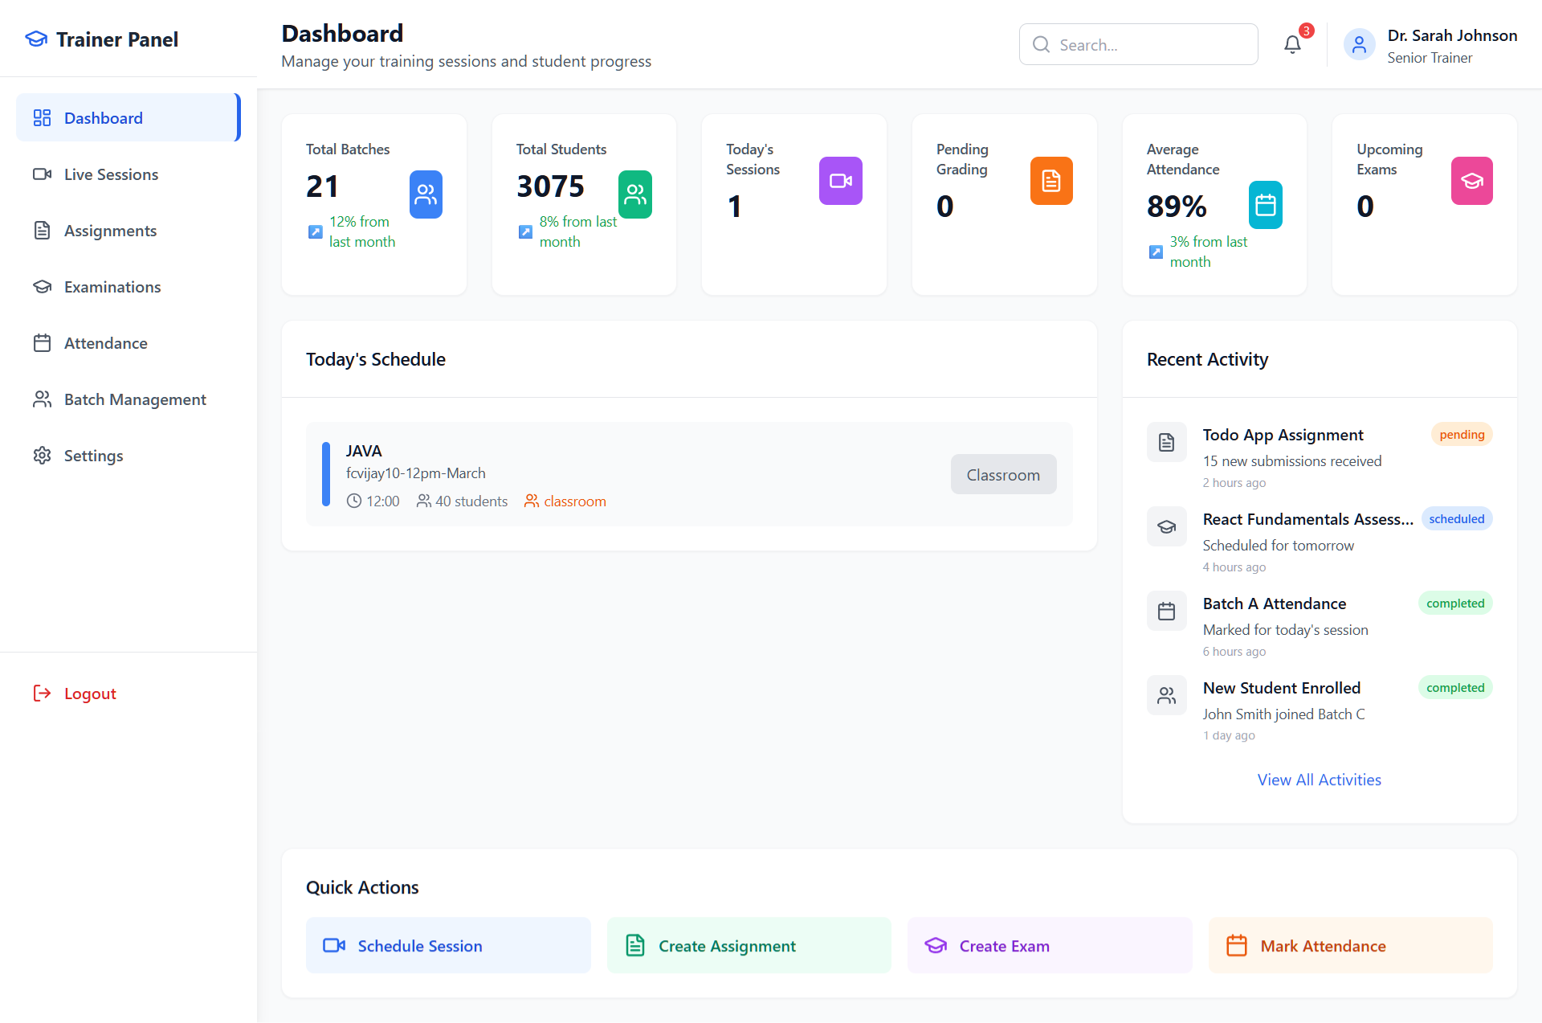

- Live Session:
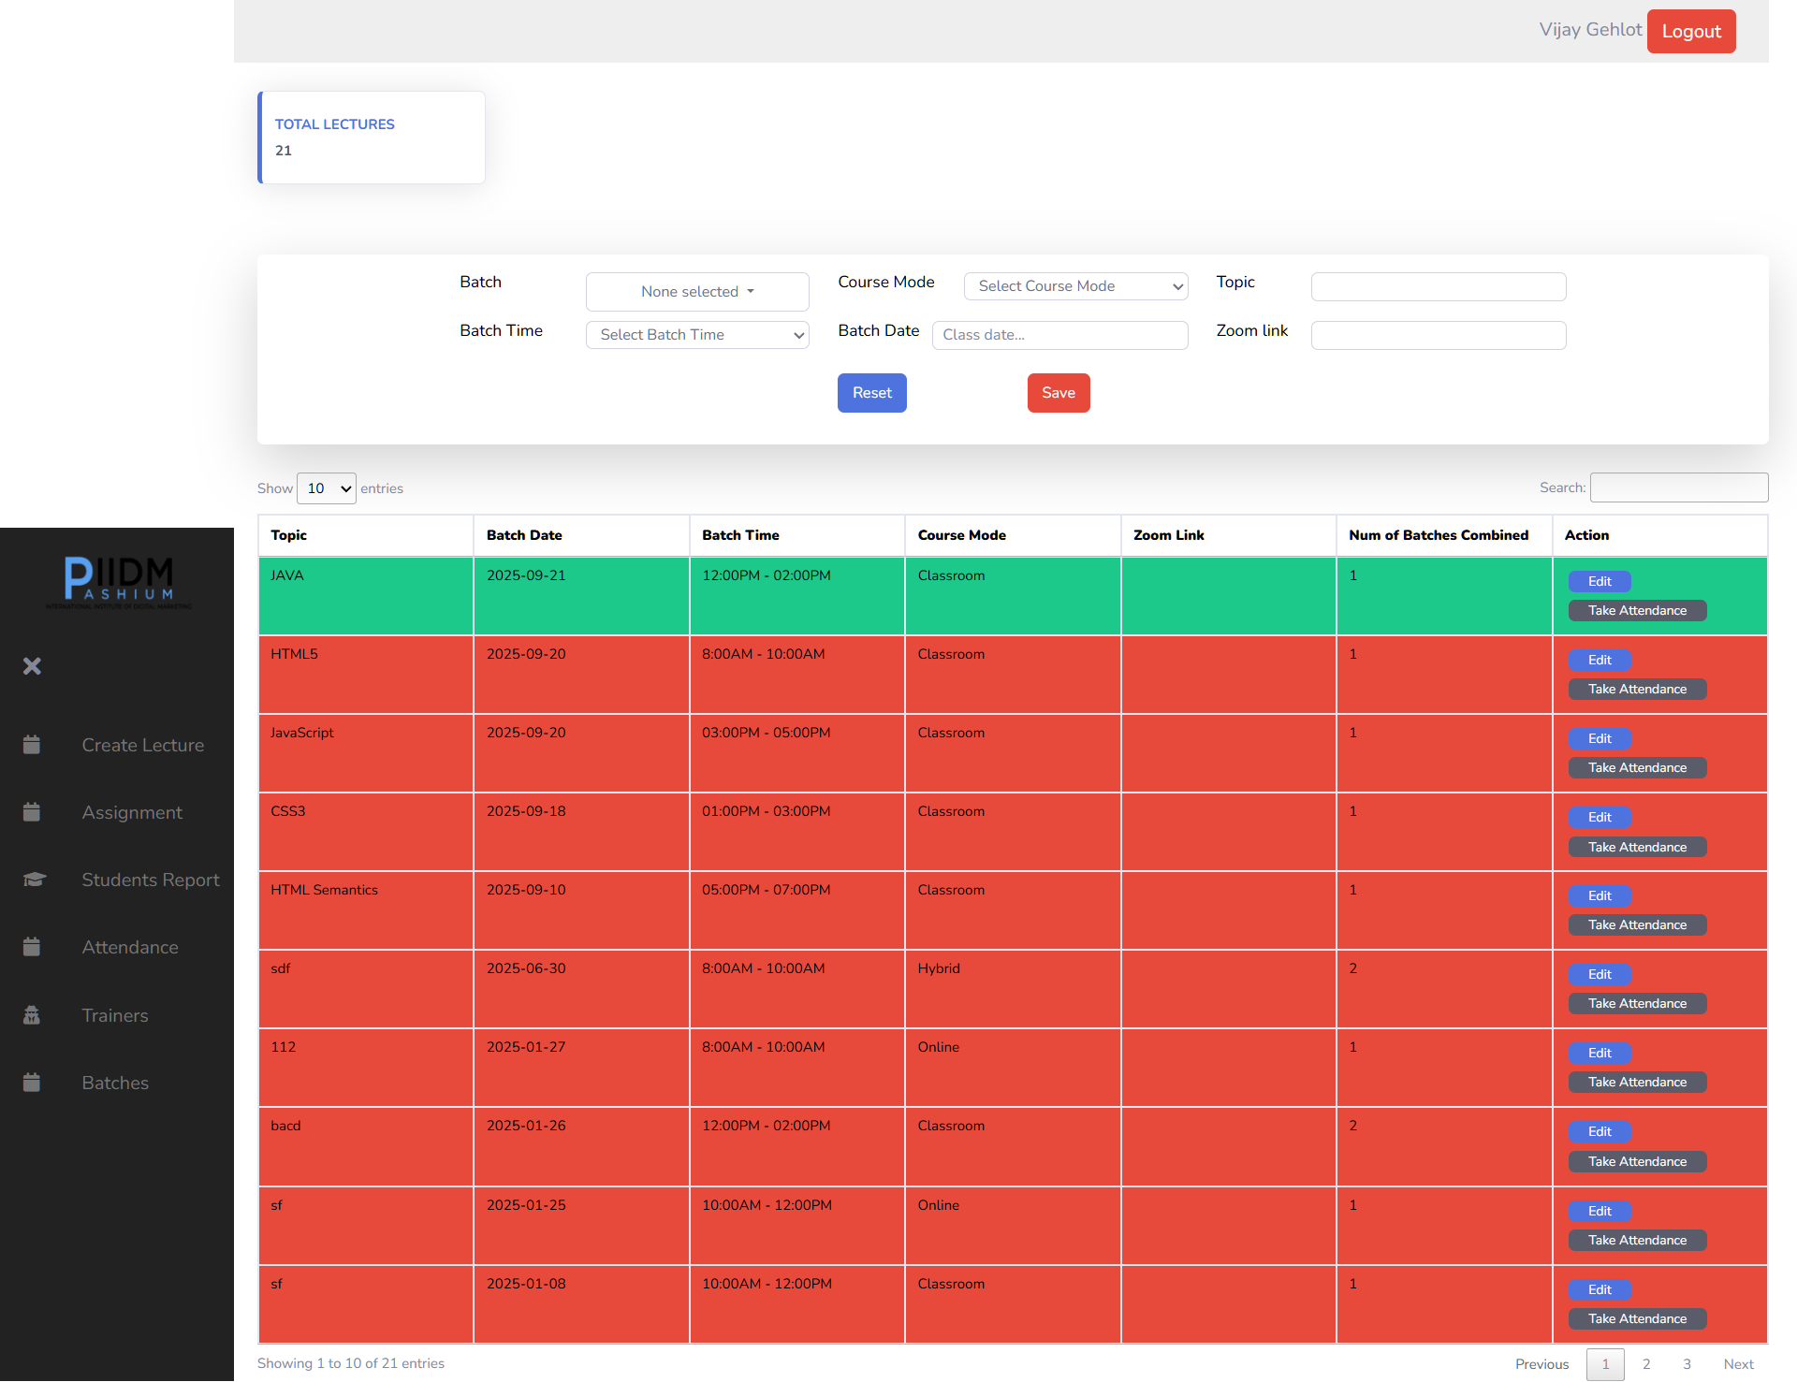
Old UI:

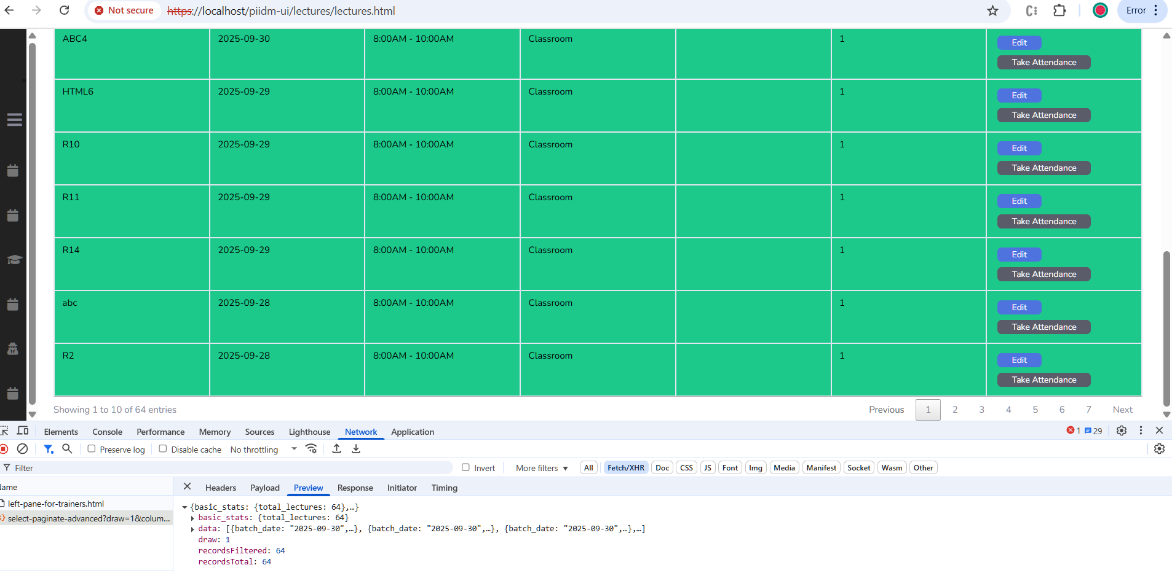
Data Table implement with 10 rows length with paginated API draw option
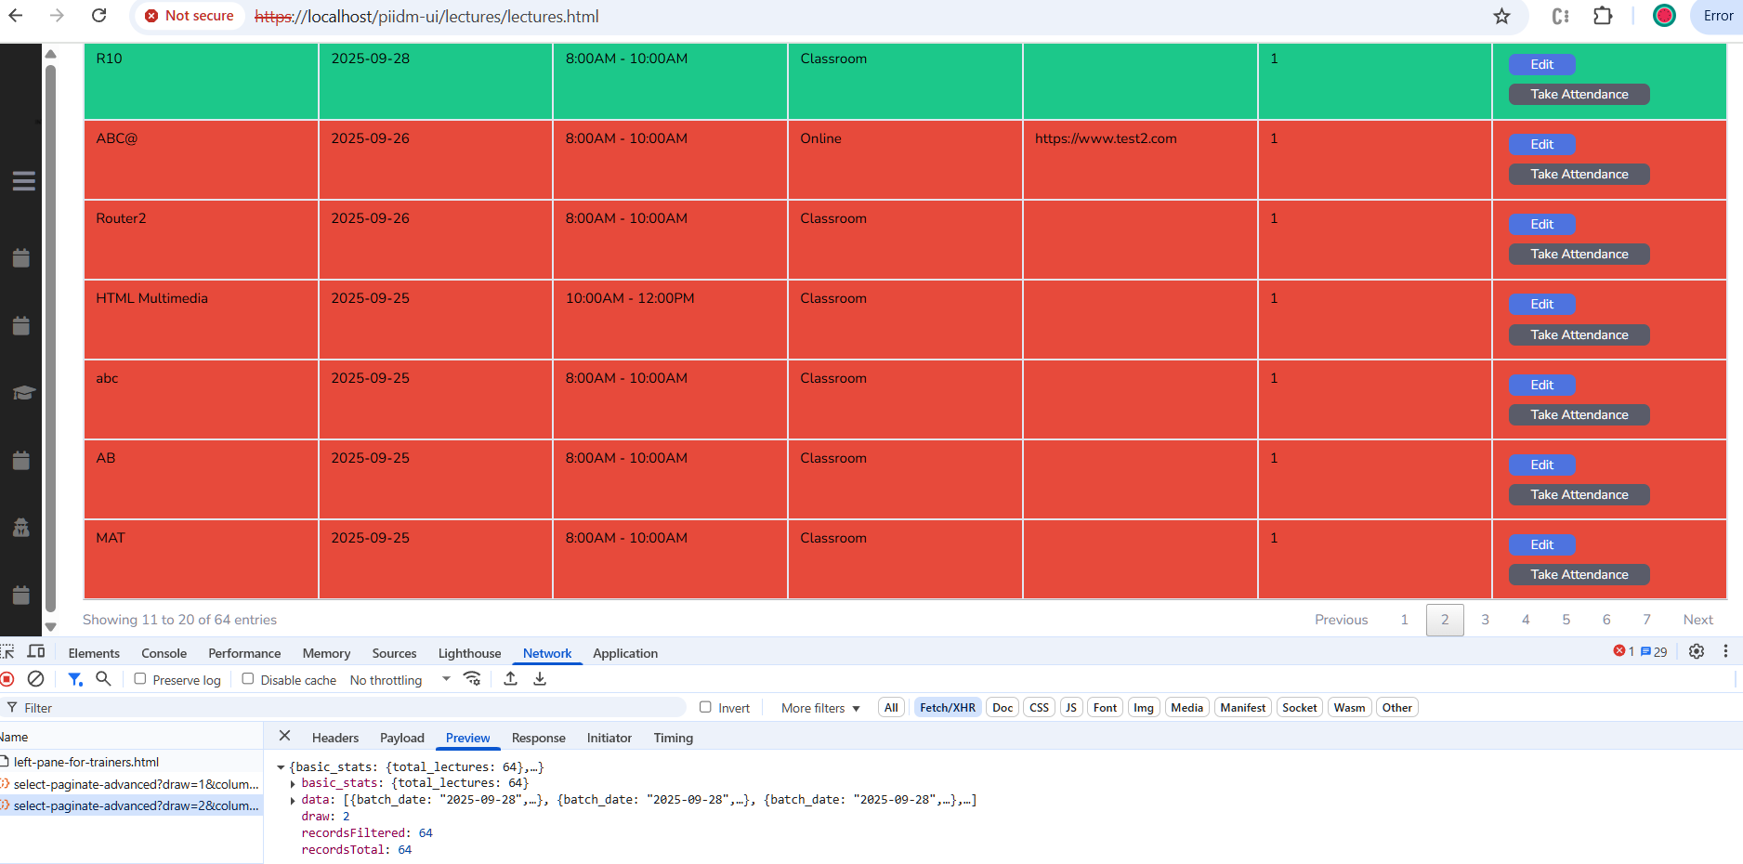
It is just an icon, not edit and take attendance button functionality like as Old UI.
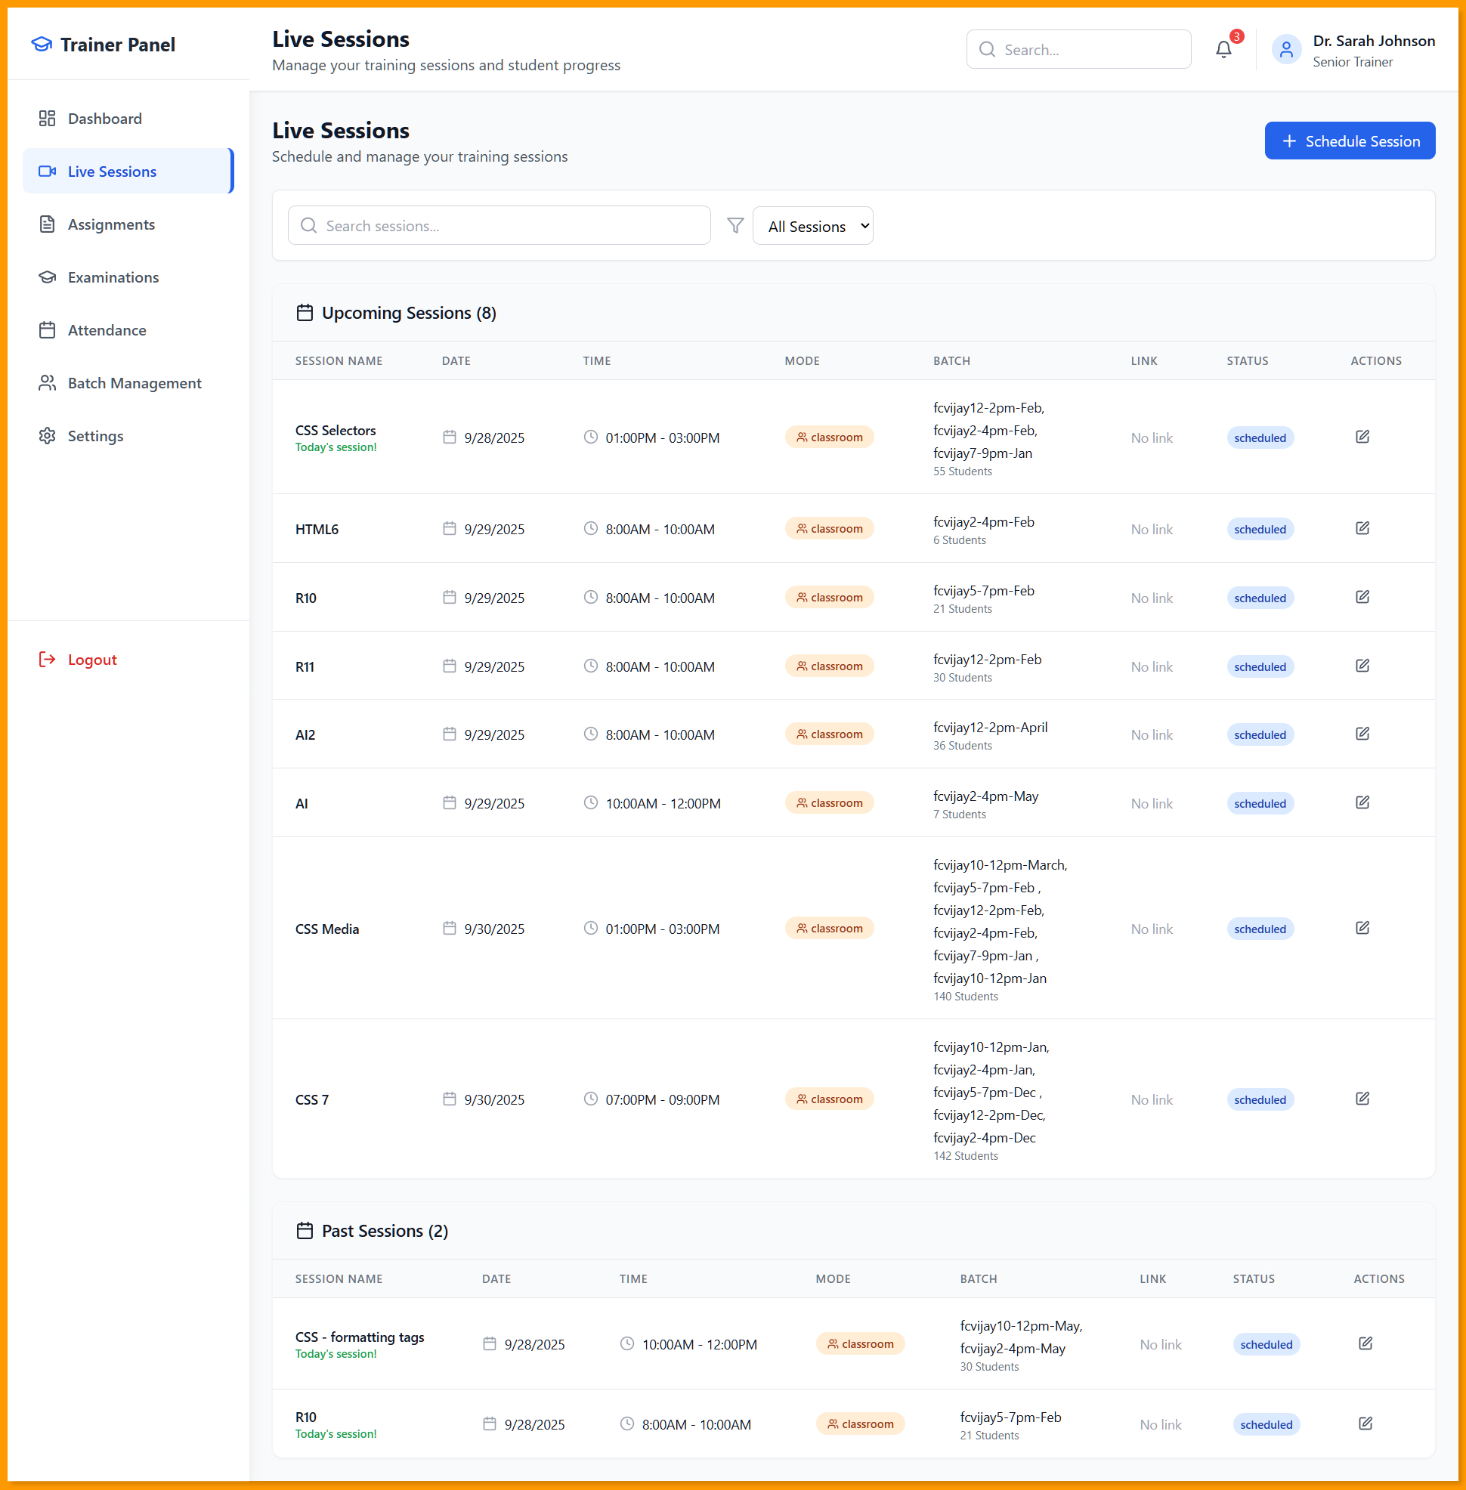
New UI:
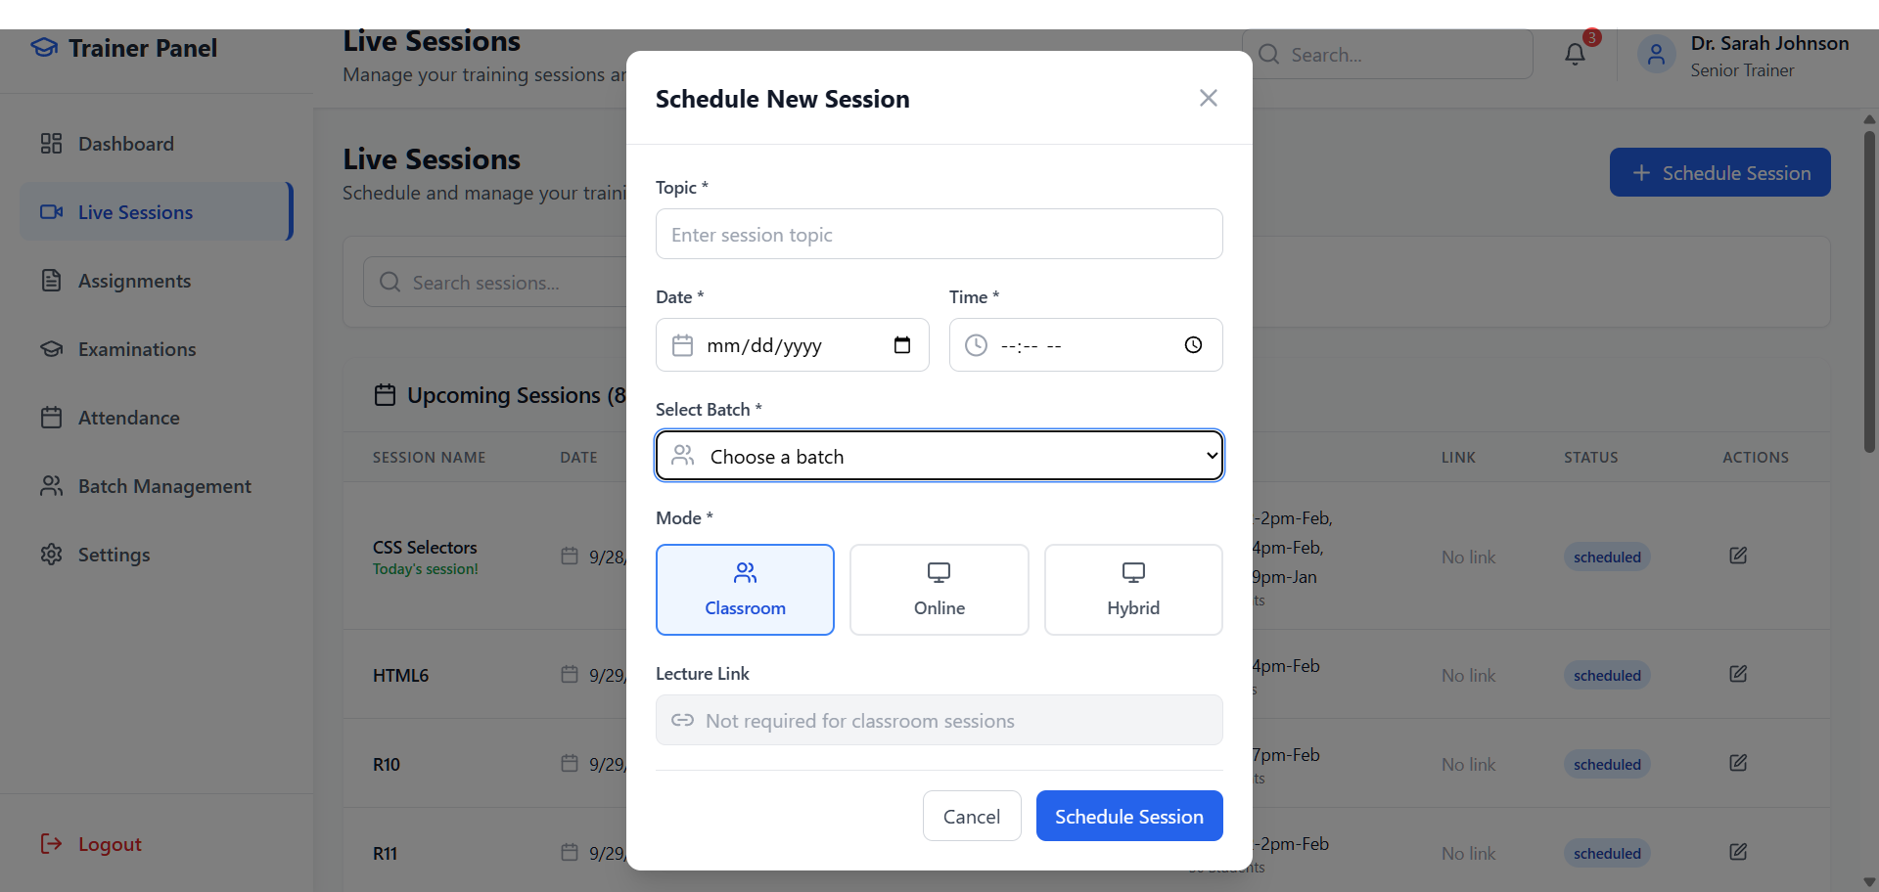

* In New UI, Normal Table used and 10 rows per table displayed only and tried to implement the Data Table for other data , it will conflict with other functionality of code in React and also UI changes.

* To create the new Session/Lecture, new UI has Schedule Session button instead Save button and Cancel
button where as old UI has Reset and Save button. New UI open the Model when click on Schedule
Session button. Only one batch can be selected from dropdown for one session where as old UI has multiple batches (dropdown checkboxes) select.

1. Lecture API ( Get the all-fields values except the batch field ): /lecture/select-paginate-advanced?draw=1&columns%5B0%5D%5Bdata%5D=topic&columns%5B0%5D%5Bname%5D=&columns%5B0%5D%5Bsearchable%5D=true&columns%5B0%5D%5Borderable%5D=false&columns%5B0%5D%5Bsearch%5D%5Bvalue%5D=&columns%5B0%5D%5Bsearch%5D%5Bregex%5D=false&columns%5B1%5D%5Bdata%5D=batch_date&columns%5B
1%5D%5Bname%5D=&columns%5B1%5D%5Bsearchable%5D=true&columns%5B1%5D%5Borderable%5D=false&columns%5B1%5D%5Bsearch%5D%5Bvalue%5D=&columns%5B1%5D%5Bsearch%5D%5Bregex%5D=false&columns%5B2%5D%5Bdata%5D=batch_time.name&columns%5B2%5D%5Bname%5D=&columns%5B2%5D%5Bsearchable%5D=true&columns%5B2%5D%5Borderable%5D=false&columns%5B2%5D%5Bsearch%5D%5Bvalue%5D=&columns%5B2%5D%5Bsearch%5D%5Bregex%5D=false&columns%5B3%5D%5Bdata%5D=course_mode.name&columns%5B3%5D%5Bname%5D=&columns%5B3%5D%5Bsearchable%5D=true&columns%5B3%5D%5Borderable%5D=false&columns%5B3%5D%5Bsearch%5D%5Bvalue%5D=&columns%5B3%5D%5Bsearch%5D%5Bregex%5D=false&columns%5B4%5D%5Bdata%5D=zoom_link&columns%5B4%5D%5Bname%5D=&columns%5B4%5D%5Bsearchable%5D=true&columns%5B4%5D%5Borderable%5D=false&columns%5B4%5D%5Bsearch%5D%5Bvalue%5D=&columns%5B4%5D%5Bsearch%5D%5Bregex%5D=false&columns%5B5%5D%5Bdata%5D=total_combined_batches&columns%5B5%5D%5Bname%5D=&columns%5B5%5D%5Bsearchable%5D=true&columns%5B5%5D%5Borderable%5D=false&columns%5B5%5D%5Bsearch%5D%5Bvalue%5D=&columns%5B5%5D%5Bsearch%5D%5Bregex%5D=false&columns%5B6%5D%5Bdata%5D=&columns%5B6%5D%5Bname%5D=&columns%5B6%5D%5Bsearchable%5D=true&columns%5B6%5D%5Borderable%5D=false&columns%5B6%5D%5Bsearch%5D%5Bvalue%5D=&columns%5B6%5D%5Bsearch%5D%5Bregex%5D=false&start=0&length=10&search%5Bvalue%5D=&search%5Bregex%5D=false&_=1753018158729

2. Batch API (Get Batch field): /batch/select-paginate-advanced?draw=1&columns%5B0%5D%5Bdata%5D=batch_num&columns%5B0%5D%5Bname%5D=&columns%5B0%5D%5Bsearchable%5D=true&columns%5B0%5D%5Borderable%5D=false&columns%5B0%5D%5Bsearch%5D%5Bvalue%5D=&columns%5B0%5D%5Bsearch%5D%5Bregex%5D=false&columns%5B1%5D%5Bdata%5D=&columns%5B1%5D%5Bname%5D=&columns%5B1%5D%5Bsearchable%5D=true&columns%5B1%5D%5Borderable%5D=false&columns%5B1%5D%5Bsearch%5D%5Bvalue%5D=&columns%5B1%5D%5Bsearch%5D%5Bregex%5D=false&columns%5B2%5D%5Bdata%5D=name&columns%5B2%5D%5Bname%5D=&columns%5B2%5D%5Bsearchable%5D=true&columns%5B2%5D%5Borderable%5D=false&columns%5B2%5D%5Bsearch%5D%5Bvalue%5D=&columns%5B2%5D%5Bsearch%5D%5Bregex%5D=false&columns%5B3%5D%5Bdata%5D=batch_date&columns%5B3%5D%5Bname%5D=&columns%5B3%5D%5Bsearchable%5D=true&columns%5B3%5D%5Borderable%5D=false&columns%5B3%5D%5Bsearch%5D%5Bvalue%5D=&columns%5B3%5D%5Bsearch%5D%5Bregex%5D=false&columns%5B4%5D%5Bdata%5D=batch_time.name&columns%5B4%5D%5Bname%5D=&columns%5B4%5D%5Bsearchable%5D=true&columns%5B4%5D%5Borderable%5D=false&columns%5B4%5D%5Bsearch%5D%5Bvalue%5D=&columns%5B4%5D%5Bsearch%5D%5Bregex%5D=false&columns%5B5%5D%5Bdata%5D=branch.name&columns%5B5%5D%5Bname%5D=&columns%5B5%5D%5Bsearchable%5D=true&columns%5B5%5D%5Borderable%5D=false&columns%5B5%5D%5Bsearch%5D%5Bvalue%5D=&columns%5B5%5D%5Bsearch%5D%5Bregex%5D=false&columns%5B6%5D%5Bdata%5D=course.name&columns%5B6%5D%5Bname%5D=&columns%5B6%5D%5Bsearchable%5D=true&columns%5B6%5D%5Borderable%5D=false&columns%5B6%5D%5Bsearch%5D%5Bvalue%5D=&columns%5B6%5D%5Bsearch%5D%5Bregex%5D=false&columns%5B7%5D%5Bdata%5D=course_mode.name&columns%5B7%5D%5Bname%5D=&columns%5B7%5D%5Bsearchable%5D=true&columns%5B7%5D%5Borderable%5D=false&columns%5B7%5D%5Bsearch%5D%5Bvalue%5D=&columns%5B7%5D%5Bsearch%5D%5Bregex%5D=false&columns%5B8%5D%5Bdata%5D=trainer.name&columns%5B8%5D%5Bname%5D=&columns%5B8%5D%5Bsearchable%5D=true&columns%5B8%5D%5Borderable%5D=false&columns%5B8%5D%5Bsearch%5D%5Bvalue%5D=&columns%5B8%5D%5Bsearch%5D%5Bregex%5D=false&columns%5B9%5D%5Bdata%5D=total_seats&columns%5B9%5D%5Bname%5D=&columns%5B9%5D%5Bsearchable%5D=true&columns%5B9%5D%5Borderable%5D=false&columns%5B9%5D%5Bsearch%5D%5Bvalue%5D=&columns%5B9%5D%5Bsearch%5D%5Bregex%5D=false&start=0&length=10&search%5Bvalue%5D=&search%5Bregex%5D=false

- Create Lecture API: /lecture/add

- Assignments:
Old UI:
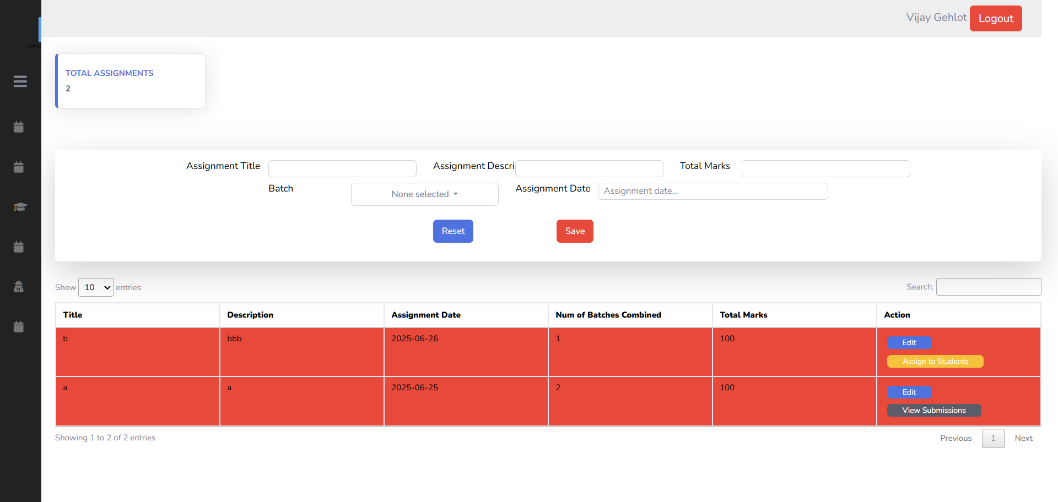

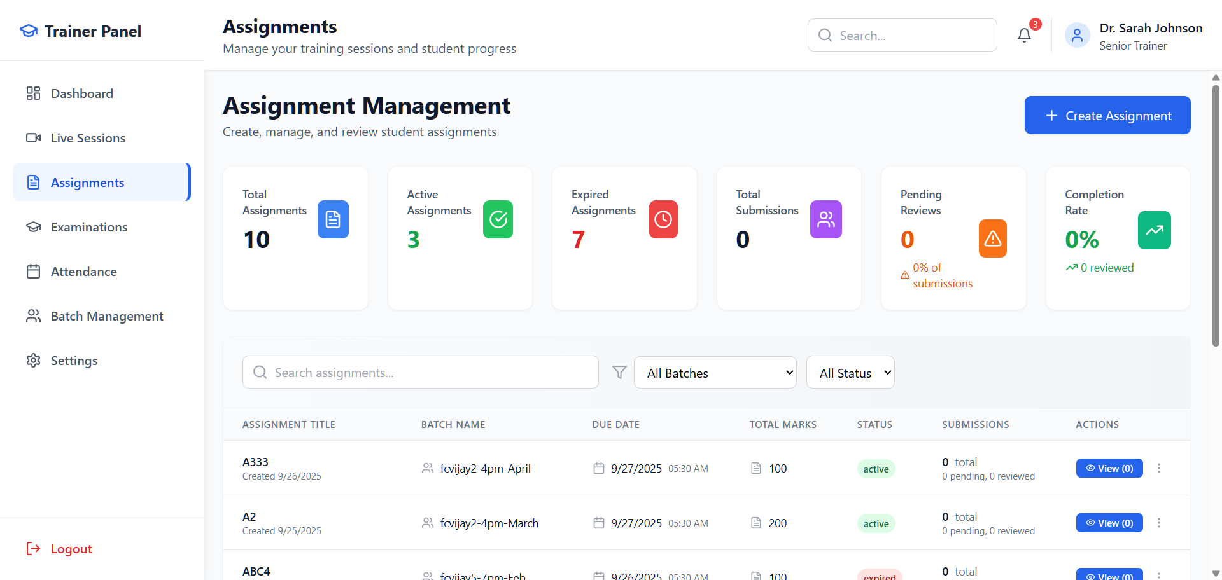
New UI:

